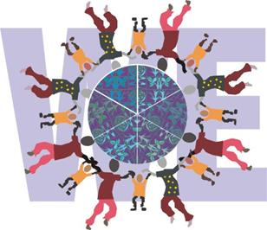

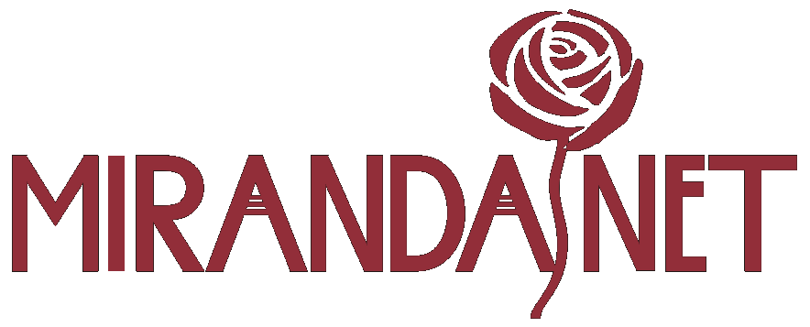

World Ecitizens

Email: contact@worldecitizens.net

Friday, 31 July 2026

Dear Colleague
World Ecitizens is a registered Charity and works in partnership with MirandaNet and a network of UK public and private sector organisations to bridge both the digital and cultural divide of children in all countries. The charity engages a particular focus on projects linked to schools in the UK and how they might internationally engage with other schools and cultures using new media technology solutions as an integrated form of citizenship through ICT.
The following statements help to explain the main purposes of the World Ecitizens charity:
What is the World Ecitizens Project?
The World Ecitizens (WE) Project aims to encourage understanding between peoples and communities and to share the fascinating diversity within nations and across the world. WE take responsibility for our actions and strive to make the world a better place.
The WE web-based learning environment is a rich resource for educational collaboration in topics such as responsible citizenship, mutual respect, combating social injustice and conflict prevention and resolution. WE participants can build projects together, join in debates and develop electronic portfolios. Young people achieve World Ecitizen status when they publish a contribution to the WE gallery.
Giving young people a voice
Since January 2003 communities and classes of young people in the UK have presented posters, video clips and comic strips about citizenship issues that concern them. Some of the young people have been working with artists and writers in residence. So far, homelessness and international citizenship have emerged as major areas of concern.
The World Ecitizens Ejournal
The WEjournal is a gateway where the WE community leaders and teachers can share ideas for developing humanitarian projects using ICT as a bridge. Leaders who publish in the WE journal achieve a Fellowship in World Ecitizenship for using elearning to draw the peoples of the world together.
More information can be found on the World Ecitizens website located at: http://www.worldecitizens.net/wecitizens/index.htm
How your organisation can support World Ecitizens (WE)
There are three types of support that you might consider giving to WE:
An Annual Charitable Donation
We welcome any level, form or type of financial contribution and this would be payable to ‘World Ecitizens’ and sent to:
Mrs Lynne Coombs, WE Administrator, 1 Beale’s Barton, Holt, Wiltshire, BA14 6QG.
Organisational Partnerships
This might involve becoming engaged in one of our many WE projects and could take the form of assistance in kind, e.g. seconded members of your organisation working on WE projects with schools, providing useful resources in the form of venues and other facilities etc. We already have a number of useful company partnerships and so your involvement would add to this valuable learning network. For further discussions on how your organisation might become a partner to either World Ecitizens or MirandaNet please contact our Director: Tina Preston: christina@mirandanet.ac.uk .
Major Sponsorships
If you look at our parent MirandaNet Fellowship website at: http://www.mirandanet.ac.uk/ you will see that we are in partnership with Bath Spa University who offer our Fellows postgraduate Professional Learning qualifications for work-based enquiry projects related to their ICT continuing professional development (CPD). Qualifications include an MA and MTeach Professional Learning with opportunities to progress onto PhD and many of our Fellows would benefit from company-sponsored scholarships – this would make a real difference!
As part of their partnership with MirandaNet, Bath Spa University have set up a new Centre for Educational Innovation and Technology (CEIT), which is linked to the MirandaNet Academy in Bath that wishes to enage in and report useful applied teacher research projects that impact on pupil/student learning and help to improve the schools they work in. We are looking for a major private sector sponsor to both adopt and support the CEIT as part of a long-term Joint Collaborative Project. For further discussions on how your organisation might adopt the CEIT please contact: Dr Steven J Coombs, Head of CPD & Chair of the Professional Master’s Programme and MirandaNet Academy at Bath Spa University: s.coombs@bathspa.ac.uk .
We sincerely invite your support and partnership to help us fund and sponsor projects to help bridge cultures and communities through the use of ICT and other New Media technologies. We look forward to your early reply.
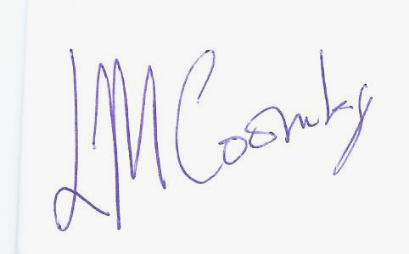
Yours sincerely,

Lynne Coombs
MirandaNet Manager, Administrator for World Citizens
contact@worldecitizens.net

