7 March 2003

Foundation Meeting in Düsseldorf:
EENet is registered Association

On 7 March 2003 the Association "European Experts' Network for Education and Technology" was founded in the Düsseldorf State Chancellory. A more than five-year informal co-operation has been assured this way. The aim of the Association is to connect, consolidate, and disseminate knowledge about ICT-related transformations in European school education. The experts' network with members from Norway, Denmark, Finland, Ireland, Germany, Austria, and Sweden analyses and reflects upon the processes linked to the transition towards the knowledge society. It intends to link theoretical insights and research experiences with policy aims and their implementation in order to contribute to the quality of European school education.

The eight founding members consist of:  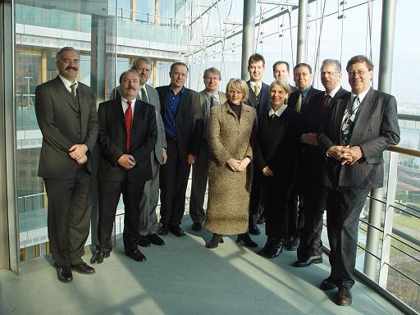 | Jostein Osnes (3rd from the left) from the Norwegian Board of Education (NO), Per Thorboll (4th from the left) from UNI-C The Danish IT Centre for Education and Research (DK), Jari Koivisto (5th from the left) from NBE National Board of Education (FI), Eileen Freeman (mid left) (IE), Ursula Esser (mid right) und Ralf Münchow (5th from the right) from Schools Online e.V. (DE), Harald Gapski (4th from the right) from the ecmc European Centre for Media Competence GmbH (DE), Helmut Stemmer (3rd from the right) from Education Highway - Innovation Centre for School and New Technology GmbH (AT), and Carl Holmberg (2nd from the right) from CFL The Swedish Agency for Flexible Learning (SE).
Carl Holmberg was elected Chair of the Board, Eileen Freeman Vice-Chair, Per Thorbøll Treasurer, Harald Gapski Secretary, and Ritva Kivi (represented by Jari Koivisto) member. After the formal Foundation Miriam Meckel, State Secretary for Europe, International Affairs and Media of NRW, congratulated the present members on this new phase of collaboration. W. J. Pelgrum (1st from the right) from University Twente, The Netherlands, was elected "Advisory Member" of the Association. He presented up-to-date international research findings dealing with the New Media as an agent for changing the learning culture in schools.
Carl Holmberg (Chair): "With this Foundation we continue our successful work in EENet, and at the same time provide it with a solid basis. Our current working programme describes the realisation of seminars and conferences, the extension of our observing activities, and the invitation of new potential members. I am looking forward to the further international co-operation in this network." |  | 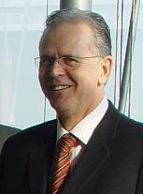
 | Kontakt
EENet European Experts’ Network for Education and Technology
Bergstr. 8 / 10th floor
45770 Marl
http://www.eenet.org info@eenet.org
Tel.: +49 (0) 2365-9404-0 Harald Gapski (EENet Secretary)
Fax: +49 (0) 2365-9404-29

