

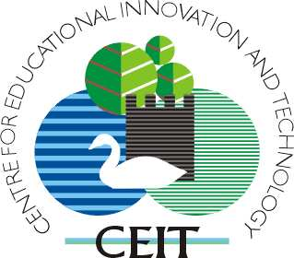

MirandaNet Academy
&
Centre for Educational Innovation and Technology

presents a one-day seminar and workshop on

Visual Learning & Pedagogy

Thursday 27th April 2006

Venue – Bath Spa University, Newton Park, TN.101

10am Registration & refreshments

10:30am Welcome Steven Coombs, Head of CPD & Chair of the PMP.

10:45am Visual Learning and the pedagogy of Concept Maps
Christina Preston – Director of MirandaNet International.

11:30am Coffee break

11:45 pm Interactive Whiteboards – some useful ideas for classrooms! John Cuthell, Co-Director of MirandaNet & Bath Spa University CPD consultant.
12:30 pm Visual research methods: Steve Coombs. Visual scaffolding tools for enriched and accelerated learning.

1:00pm Lunch break

2:00pm 2Simple Workshop – software support for visual learners

Nigel Canin et al from 2Simple

4pm Refreshment break

4:30pm Innovative Visuals : ACTIVboard practice from around the world : Georgia Kalkanis : Learning adviser, Promethean

5:00pm Plenary & closure/evaluation – Christina Preston.

7:30pm Dinner – hosted & sponsored in Bath by 2Simple (Loch Fyne Restaurant, George Street, Bath)

Reply to Alison Denning (01225-875440) or a.denning@bathspa.ac.uk.
The campus map with Twiverton Building, BA2 9BN is at:
http://www.bathspa.ac.uk/contact/map-newton-park.asp
Directions from the website: http://www.bathspa.ac.uk/

